# **MODUL 1**

Latihan1_1. GLUT “Hello World” & Gambar Segiempat

Source code:

import pygame

from pygame.locals import *

from OpenGL.GL import *

from OpenGL.GLU import *

**def** Cube():

    glBegin(GL_QUADS)

    glVertex3f(-0.5, -0.5, 0.5)

    glVertex3f(0.5, -0.5, 0.5)

    glVertex3f(0.5, 0.5, 0.5)

    glVertex3f(-0.5, 0.5, 0.5)

    glEnd()

**def** main():

    pygame.init()

    display = (800, 600)

    pygame.display.set_mode(display, DOUBLEBUF | OPENGL)

    pygame.display.set_caption('Hello World..!!')

    gluPerspective(45, (display[0] / display[1]), 0.1, 50.0)

    glTranslatef(0.0, 0.0, -5)

    while True:

        for event in pygame.event.get():

            if event.type == pygame.QUIT:

                pygame.quit()

                quit()

        glClear(GL_COLOR_BUFFER_BIT | GL_DEPTH_BUFFER_BIT)

        Cube()

        pygame.display.flip()

        pygame.time.wait(10)

if __name__ == "__main__":

    main()

Output program:

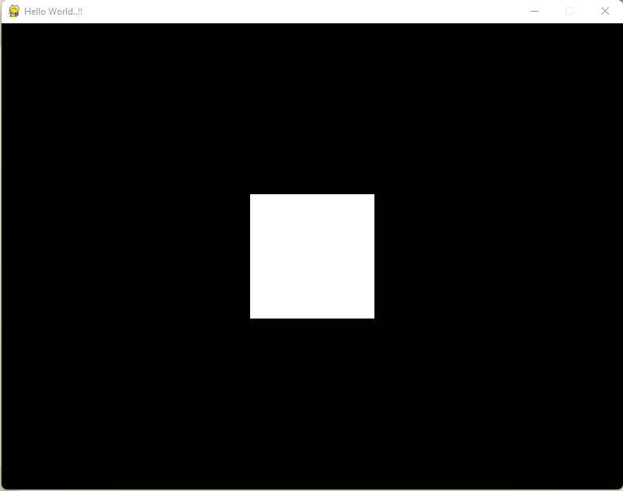

**Tugas:**

1. Ganti warna background dengan mengganti nilai glClearColor:

Hijau → glClearColor (0.0, 1.0, 0.0, 1.0)

1. Ganti warna object (segi empat) dengan mengganti nilai dalam glColor3f

Merah → glColor3f (1.0, 0.0, 0.0)

import pygame

from pygame.locals import *

from OpenGL.GL import *

from OpenGL.GLU import *

**def** Cube():

    glBegin(GL_QUADS)

    glVertex3f(-0.8, -0.8, 0.8)

    glVertex3f(0.8, -0.8, 0.8)

    glVertex3f(0.8, 0.8, 0.8)

    glVertex3f(-0.8, 0.8, 0.8)

    glEnd()

**def** init():

    glClearColor (0.0, 1.0, 0.0, 1.0);   *#background colour hijau*

    glColor3f(1.0, 0.0, 0.0);            *#object colour red*

    glMatrixMode (GL_PROJECTION);

    glLoadIdentity();                    *#load identity*

    glOrtho(-1.0, 1.0, -1.0, 1.0, -1.0, 1.0);   *#projection*

**def** main():

    pygame.init()

    display = (800, 600)

    pygame.display.set_mode(display, DOUBLEBUF | OPENGL)

    pygame.display.set_caption('Hello World..!!')

    gluPerspective(45, (display[0] / display[1]), 0.1, 50.0)

    glTranslatef(0.0, 0.0, -5)

    init()

    while True:

        for event in pygame.event.get():

            if event.type == pygame.QUIT:

                pygame.quit()

                quit()

        glClear(GL_COLOR_BUFFER_BIT | GL_DEPTH_BUFFER_BIT)

        Cube()

        pygame.display.flip()

        pygame.time.wait(10)

if __name__ == "__main__":

    main()

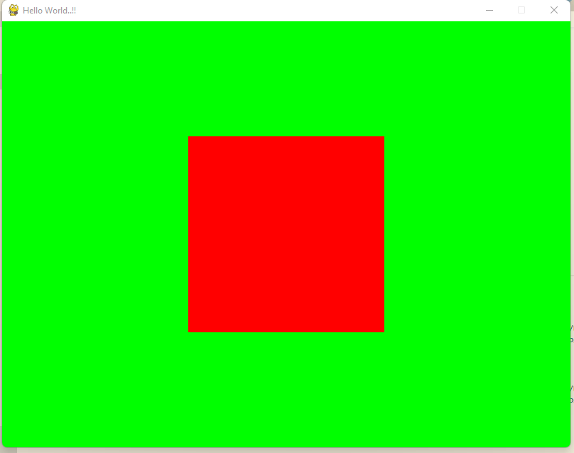

Ganti warna background dengan mengganti nilai glClearColor:

Biru → glClearColor (0.0, 0.0, 1.0, 1.0)

Ganti warna object (segi empat) dengan mengganti nilai dalam glColor3f

Putih → glColor3f (1.0, 1.0, 1.0)

import pygame

from pygame.locals import *

from OpenGL.GL import *

from OpenGL.GLU import *

**def** Cube():

    glBegin(GL_QUADS)

    glVertex3f(-0.8, -0.8, 0.8)

    glVertex3f(0.8, -0.8, 0.8)

    glVertex3f(0.8, 0.8, 0.8)

    glVertex3f(-0.8, 0.8, 0.8)

    glEnd()

**def** init():

    glClearColor(0.0, 0.0, 1.0, 1.0); *#Set background color to blue*

    glColor3f(1.0, 1.0, 1.0);          *#set object color to white*

    glMatrixMode (GL_PROJECTION);

    glLoadIdentity();                    *#load identity*

    glOrtho(-1.0, 1.0, -1.0, 1.0, -1.0, 1.0);   *#projection*

**def** main():

    pygame.init()

    display = (800, 600)

    pygame.display.set_mode(display, DOUBLEBUF | OPENGL)

    pygame.display.set_caption('Hello World..!!')

    gluPerspective(45, (display[0] / display[1]), 0.1, 50.0)

    glTranslatef(0.0, 0.0, -5)

    init()

    while True:

        for event in pygame.event.get():

            if event.type == pygame.QUIT:

                pygame.quit()

                quit()

        glClear(GL_COLOR_BUFFER_BIT | GL_DEPTH_BUFFER_BIT)

        Cube()

        pygame.display.flip()

        pygame.time.wait(10)

if __name__ == "__main__":

    main()

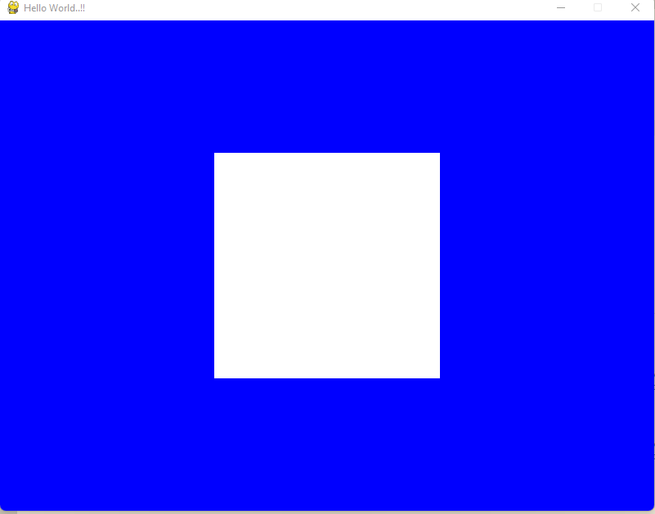

Ganti warna background dengan mengganti nilai glClearColor:

Kuning → glClearColor (1.0, 1.0, 0.0, 1.0)

Ganti warna object (segi empat) dengan mengganti nilai dalam glColor3f

Abu-Abu → glColor3f (0.5, 0.5, 0.5)

import pygame

from pygame.locals import *

from OpenGL.GL import *

from OpenGL.GLU import *

**def** Cube():

    glBegin(GL_QUADS)

    glVertex3f(-0.8, -0.8, 0.8)

    glVertex3f(0.8, -0.8, 0.8)

    glVertex3f(0.8, 0.8, 0.8)

    glVertex3f(-0.8, 0.8, 0.8)

    glEnd()

**def** init():

    glClearColor(1.0, 1.0, 0.0, 1.0); *# Set background color to yellow*

    glColor3f(0.5, 0.5, 0.5);          *# Set object color to gray*

    glMatrixMode (GL_PROJECTION);

    glLoadIdentity();                    *#load identity*

    glOrtho(-1.0, 1.0, -1.0, 1.0, -1.0, 1.0);   *#projection*

**def** main():

    pygame.init()

    display = (800, 600)

    pygame.display.set_mode(display, DOUBLEBUF | OPENGL)

    pygame.display.set_caption('Hello World..!!')

    gluPerspective(45, (display[0] / display[1]), 0.1, 50.0)

    glTranslatef(0.0, 0.0, -5)

    init()

    while True:

        for event in pygame.event.get():

            if event.type == pygame.QUIT:

                pygame.quit()

                quit()

        glClear(GL_COLOR_BUFFER_BIT | GL_DEPTH_BUFFER_BIT)

        Cube()

        pygame.display.flip()

        pygame.time.wait(10)

if __name__ == "__main__":

    main()

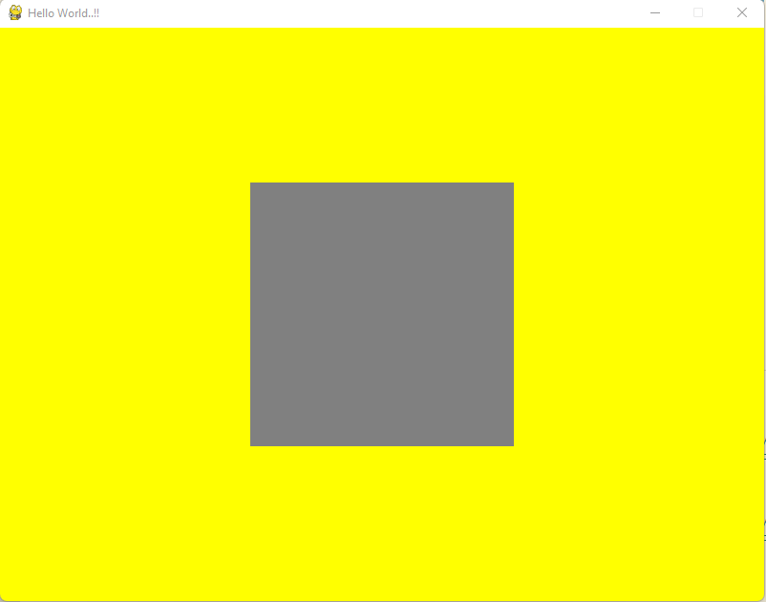

1. Ganti ukuran object dengan mengganti nilai vertex pada object QL_QUADS
2. Perbesar ukuran window dengan mengganti nilai pada glutInitWindowSize
3. Ganti nilai pada glutInitWindowPosition, lihat dan perhatikan perubahan yang terjadi pada Window

import pygame

from pygame.locals import *

from OpenGL.GL import *

from OpenGL.GLU import *

**def** Cube():

    glBegin(GL_QUADS)

    glVertex3f(-1.6, -1.6, 1.6)

    glVertex3f(1.6, -1.6, 1.6)

    glVertex3f(1.6, 1.6, 1.6)

    glVertex3f(-1.6, 1.6, 1.6)

    glEnd()

**def** init():

    glClearColor(1.0, 1.0, 0.0, 1.0)  *# Set background color to yellow*

    glColor3f(0.5, 0.5, 0.5)  *# Set object color to gray*

    glMatrixMode(GL_PROJECTION)

    glLoadIdentity()

    gluPerspective(45, (800 / 600), 0.1, 50.0)

    glTranslatef(0.0, 0.0, -5)

**def** main():

    pygame.init()

    display = (400, 300)

    pygame.display.set_mode(display, DOUBLEBUF | OPENGL)

    pygame.display.set_caption('Hello World..!!')

    init()

    while True:

        for event in pygame.event.get():

            if event.type == pygame.QUIT:

                pygame.quit()

                quit()

        glClear(GL_COLOR_BUFFER_BIT | GL_DEPTH_BUFFER_BIT)

        Cube()

        pygame.display.flip()

        pygame.time.wait(10)

if __name__ == "__main__":

    main()

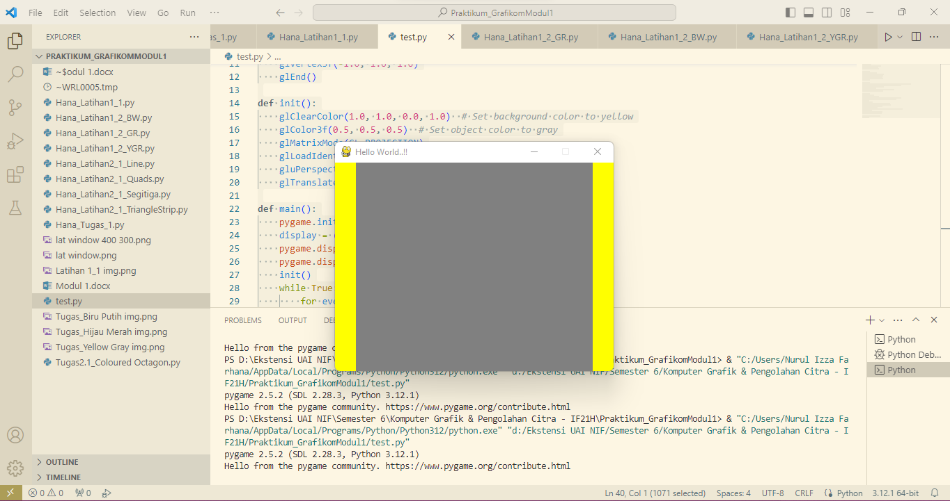

Display Window ukuran 400, 600

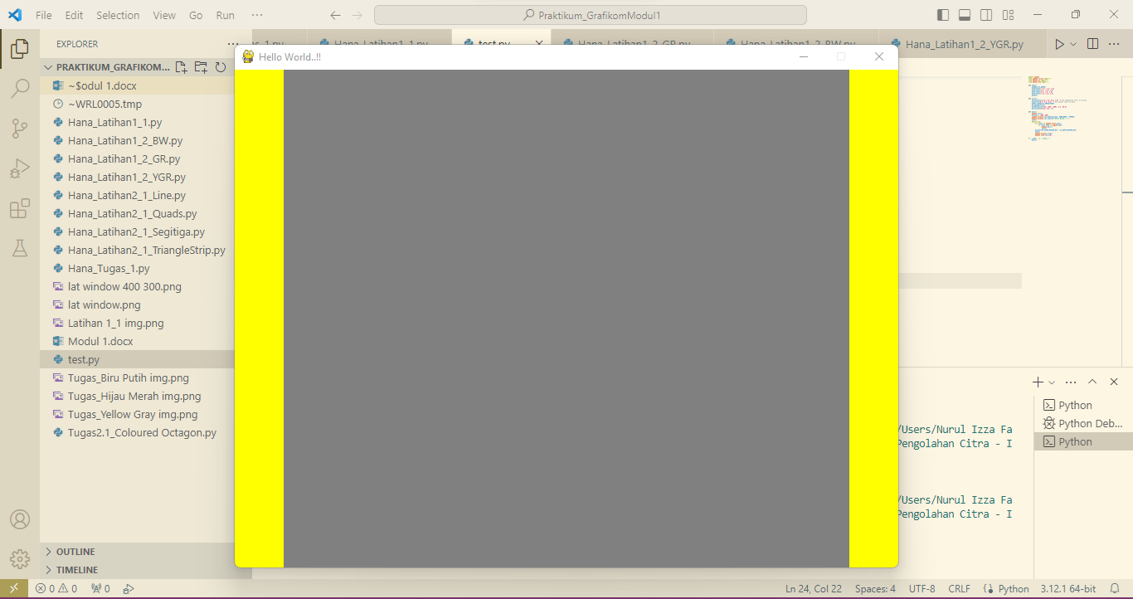

Display Window ukuran 800, 600

1. Kesimpulan

Dalam latihan ini, kita memahami dasar penggunaan Pygame dan PyOpenGL untuk membuat dan menampilkan objek 3D sederhana dalam window. Fungsi-fungsi dasar seperti `glClearColor`, `glColor3f`, `glVertex2f`, `glutInitWindowSize`, dan `glutInitWindowPosition` memiliki peran krusial. `glClearColor` digunakan untuk mengubah warna background window, `glColor3f` untuk merubah warna objek, `glVertex2f` untuk mengubah koordinat objek, dan `glutInitWindowSize` dan `glutInitWindowPosition` untuk mengatur ukuran dan posisi window. Kesimpulannya, latihan ini memberikan dasar yang kuat untuk eksplorasi lebih lanjut dalam pengembangan grafis dengan Python dan OpenGL.

# **MODUL 2: Open GL Primitives**

Ketiklah kode program berikut menggunakan notepad, simpan dengan nama Nama_latihan2_1.py Latihan 2_1. Segitiga

import pygame

from pygame.locals import *

from OpenGL.GL import *

from OpenGL.GLU import *

**def** Triangle():

    glBegin(GL_TRIANGLES)

    glVertex3f(-0.8, -0.8, 0.8)

    glVertex3f(0.8, -0.8, 0.8)

    glVertex3f(0.8, 0.8, 0.8)

    glVertex3f(-0.8, 0.8, 0.8)

    glEnd()

**def** init():

    glClearColor (0.8, 1.0, 0.0, 1.0);   *#background colour*

    glColor3f(0.6, 0.6, 0.6);            *#object colour*

    glMatrixMode (GL_PROJECTION);

    glLoadIdentity();                    *#load identity*

    glOrtho(-1.0, 1.0, -1.0, 1.0, -1.0, 1.0);   *#projection*

**def** main():

    pygame.init()

    display = (800, 600)

    pygame.display.set_mode(display, DOUBLEBUF | OPENGL)

    pygame.display.set_caption('Hello World..!! This is Triangle')

    gluPerspective(45, (display[0] / display[1]), 0.1, 50.0)

    glTranslatef(0.0, 0.0, -5)

    init()

    while True:

        for event in pygame.event.get():

            if event.type == pygame.QUIT:

                pygame.quit()

                quit()

        glClear(GL_COLOR_BUFFER_BIT | GL_DEPTH_BUFFER_BIT)

        Triangle()

        pygame.display.flip()

        pygame.time.wait(10)

if __name__ == "__main__":

    main()

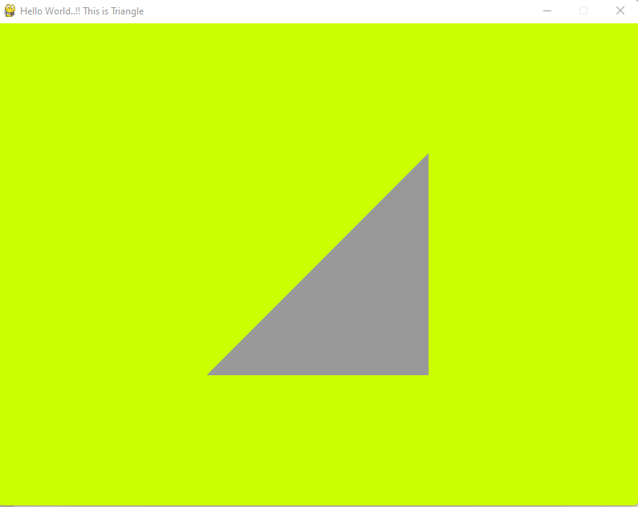

Tugas:

1. Buatlah program untuk membuat jenis openGL primitives yang lain, dengan mengganti PRIMITIVES (GL_TRIANGLES) dengan primitives yang lain,yaitu:

* GL_LINES

import pygame

from pygame.locals import *

from OpenGL.GL import *

from OpenGL.GLU import *

**def** Line():

    glBegin(GL_LINES)

    glVertex3f(-0.8, -0.8, 0.8)

    glVertex3f(0.8, -0.8, 0.8)

    glVertex3f(0.8, 0.8, 0.8)

    glVertex3f(-0.8, 0.8, 0.8)

    glEnd()

**def** init():

    glClearColor (0.8, 1.0, 0.0, 1.0);   *#background colour*

    glColor3f(0.6, 0.6, 0.6);            *#object colour*

    glMatrixMode (GL_PROJECTION);

    glLoadIdentity();                    *#load identity*

    glOrtho(-1.0, 1.0, -1.0, 1.0, -1.0, 1.0);   *#projection*

**def** main():

    pygame.init()

    display = (800, 600)

    pygame.display.set_mode(display, DOUBLEBUF | OPENGL)

    pygame.display.set_caption('Hello World..!! This is Line')

    gluPerspective(45, (display[0] / display[1]), 0.1, 50.0)

    glTranslatef(0.0, 0.0, -5)

    init()

    while True:

        for event in pygame.event.get():

            if event.type == pygame.QUIT:

                pygame.quit()

                quit()

        glClear(GL_COLOR_BUFFER_BIT | GL_DEPTH_BUFFER_BIT)

        Line()

        pygame.display.flip()

        pygame.time.wait(10)

if __name__ == "__main__":

    main()

* GL_TRIANGLESTRIP

import pygame

from pygame.locals import *

from OpenGL.GL import *

from OpenGL.GLU import *

**def** TriangleStrip():

glBegin(GL_TRIANGLE_STRIP)

glVertex3f(-0.8, -0.8, 0.8)

glVertex3f(0.8, -0.8, 0.8)

glVertex3f(0.8, 0.8, 0.8)

glVertex3f(-0.8, 0.8, 0.8)

glEnd()

**def** init():

glClearColor (0.8, 1.0, 0.0, 1.0);   *#background colour*

glColor3f(0.6, 0.6, 0.6);            *#object colour*

glMatrixMode (GL_PROJECTION);

glLoadIdentity();                    *#load identity*

glOrtho(-1.0, 1.0, -1.0, 1.0, -1.0, 1.0);   *#projection*

**def** main():

pygame.init()

display = (800, 600)

pygame.display.set_mode(display, DOUBLEBUF | OPENGL)

pygame.display.set_caption('Hello World..!!')

gluPerspective(45, (display[0] / display[1]), 0.1, 50.0)

glTranslatef(0.0, 0.0, -5)

init()

while True:

for event in pygame.event.get():

if event.type == pygame.QUIT:

pygame.quit()

quit()

glClear(GL_COLOR_BUFFER_BIT | GL_DEPTH_BUFFER_BIT)

TriangleStrip()

pygame.display.flip()

pygame.time.wait(10)

if __name__ == "__main__":

main()

* GL_QUADS

import pygame

from pygame.locals import *

from OpenGL.GL import *

from OpenGL.GLU import *

**def** Quad():

    glBegin(GL_QUADS)

    glVertex3f(-0.8, -0.8, 0.8)

    glVertex3f(0.8, -0.8, 0.8)

    glVertex3f(0.8, 0.8, 0.8)

    glVertex3f(-0.8, 0.8, 0.8)

    glEnd()

**def** init():

    glClearColor (0.8, 1.0, 0.0, 1.0);   *#background colour*

    glColor3f(0.6, 0.6, 0.6);            *#object colour*

    glMatrixMode (GL_PROJECTION);

    glLoadIdentity();                    *#load identity*

    glOrtho(-1.0, 1.0, -1.0, 1.0, -1.0, 1.0);   *#projection*

**def** main():

    pygame.init()

    display = (800, 600)

    pygame.display.set_mode(display, DOUBLEBUF | OPENGL)

    pygame.display.set_caption('Hello World..!! This is Quads')

    gluPerspective(45, (display[0] / display[1]), 0.1, 50.0)

    glTranslatef(0.0, 0.0, -5)

    init()

    while True:

        for event in pygame.event.get():

            if event.type == pygame.QUIT:

                pygame.quit()

                quit()

        glClear(GL_COLOR_BUFFER_BIT | GL_DEPTH_BUFFER_BIT)

        Quad()

        pygame.display.flip()

        pygame.time.wait(10)

if __name__ == "__main__":

    main()

1. Perhatikan urutan dari vertex untuk setiap jenis OpenGL Geometric Primitive, lampirkan output program.

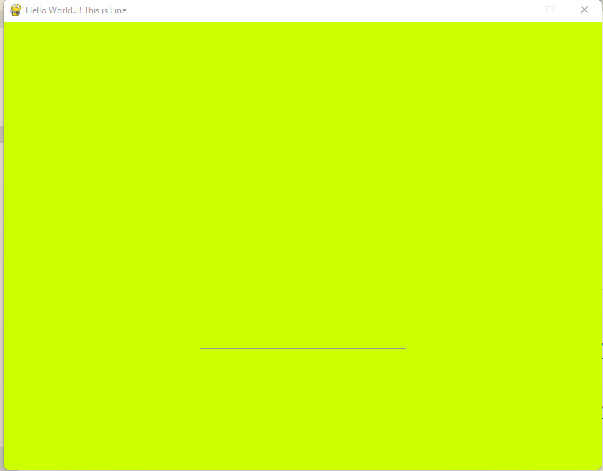

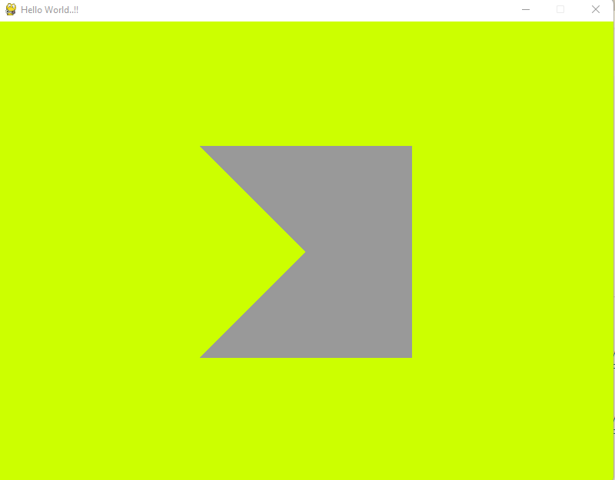

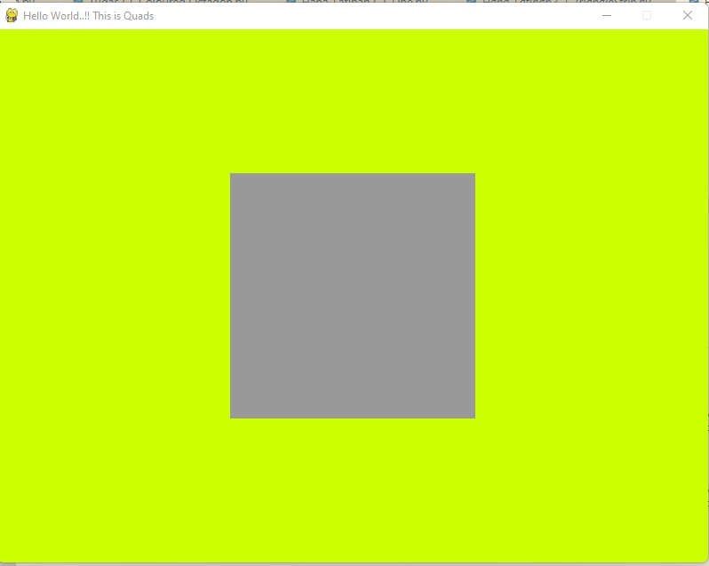

1. Buatlah program untuk menghasilkan segi delapan berwarna, dengan menambahkan fungsi glcolor3f() simpan dengan nama Tugas2.1.

import pygame

from pygame.locals import *

from OpenGL.GL import *

from OpenGL.GLU import *

**def** Octagon():

    glBegin(GL_POLYGON)

    glColor3f(1.0, 0.0, 0.0)  *# Merah*

    glVertex2f(0.0, 1.0)

    glColor3f(1.0, 0.5, 0.0)  *# Oranye*

    glVertex2f(0.7, 0.7)

    glColor3f(1.0, 1.0, 0.0)  *# Kuning*

    glVertex2f(1.0, 0.0)

    glColor3f(0.5, 1.0, 0.0)  *# Hijau*

    glVertex2f(0.7, -0.7)

    glColor3f(0.0, 1.0, 1.0)  *# Cyan*

    glVertex2f(0.0, -1.0)

    glColor3f(0.0, 0.0, 1.0)  *# Biru*

    glVertex2f(-0.7, -0.7)

    glColor3f(0.5, 0.0, 1.0)  *# Ungu*

    glVertex2f(-1.0, 0.0)

    glColor3f(1.0, 0.0, 1.0)  *# Magenta*

    glVertex2f(-0.7, 0.7)

    glEnd()

**def** init():

    glClearColor(1.0, 1.0, 1.0, 1.0)  *# Set background color to white*

    glMatrixMode(GL_PROJECTION)

    glLoadIdentity()

    gluOrtho2D(-1.5, 1.5, -1.5, 1.5)  *# Projection*

**def** main():

    pygame.init()

    display = (800, 600)

    pygame.display.set_mode(display, DOUBLEBUF | OPENGL)

    pygame.display.set_caption('Octagon with Colors')

    gluOrtho2D(-1.5, 1.5, -1.5, 1.5)

    init()

    while True:

        for event in pygame.event.get():

            if event.type == pygame.QUIT:

                pygame.quit()

                quit()

        glClear(GL_COLOR_BUFFER_BIT)

        Octagon()

        pygame.display.flip()

        pygame.time.wait(10)

if __name__ == "__main__":

    main()

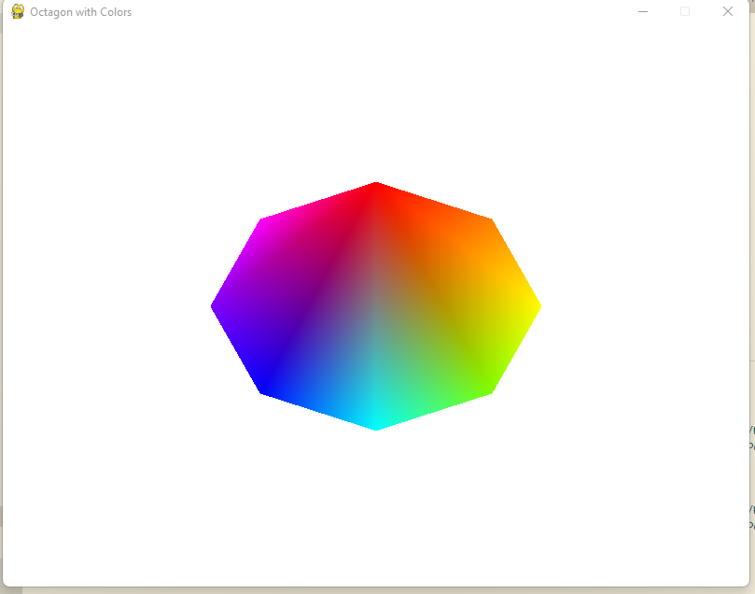

1. Kesimpulan dari Modul 2

Pemahaman konsep dasar dalam pembuatan objek grafis menggunakan titik, garis, dan poligon. Ketika membuat objek, perlu memperhatikan urutan dari setiap vertex agar bentuk objek yang dihasilkan sesuai.